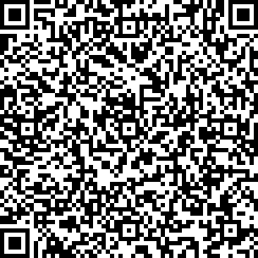 |  |  |  | 
vCard - QR code  (scan and save data)  Vcard  (scan and save data) | vCard - QR code  (scan and save data) | vCard - QR code  (scan and save data) | vCard - QR code  (scan and save data) | vCard - QR code  (scan and save data)
 |  |  |  | 
vCard - QR code  (scan and save data) | vCard - QR code  (scan and save data) | vCard - QR code  (scan and save data) | vCard - QR code  (scan and save data) | vCard - QR code  (scan and save data)  Vcard |  | vCard - QR code  (scan and save data) | vCard - QR code  (scan and save data) | vCard - QR code  (scan and save data)
Street Address  31000 Osijek, Croatia  +385 95 800 8000  Email: info@gergely.hr  Web Address | Street Address  31000 Osijek, Croatia  +385 95 800 8000  Email: info@gergely.hr  Web Address | Street Address  31000 Osijek, Croatia  +385 95 800 8000  Email: info@gergely.hr  Web Address | Street Address  31000 Osijek, Croatia  +385 95 800 8000  Email: info@gergely.hr  Web Address | Street Address  31000 Osijek, Croatia  +385 95 800 8000  Email: info@gergely.hr  Web Address

